Leena Cherian

**Retail Business Performance & Profitability Analysis**

**📌 Introduction**

The retail industry generates large volumes of transactional data that, when properly analysed, can uncover key business insights. This project aims to analyse retail sales data to identify unprofitable product categories, inventory inefficiencies, and seasonal trends in order to guide strategic decision-making.

**📄 Abstract**

This project focuses on understanding retail business performance using real-world sales data. Key objectives include calculating profit margins, identifying slow-moving or overstocked products, and examining the correlation between discounting, sales, and profitability. Through SQL, Python, and Power BI, we cleaned and analysed the data, created visual dashboards, and extracted actionable insights.

**🛠 Tools Used**

* **SQL (MySQL):** Data cleaning and aggregation
* **Python (Pandas, Seaborn):** Correlation and statistical analysis
* **Power BI:** Interactive dashboard for visual storytelling

**🔧 Steps Involved in Building the Project**

1. **Data Import & Cleaning (SQL):**
   * Loaded superstore_sales.csv into MySQL
   * Removed null/missing values and duplicate records
2. **SQL Analysis:**
   * Calculated profit margins by category and sub-category
   * Identified high-discount, low-profit items
3. **Python Analysis:**
   * Correlation analysis between discount, profit, sales, and quantity
   * Used Pandas and Seaborn to visualize insights
4. **Power BI Dashboard:**
   * + Created interactive visuals (bar, line, scatter plot) to show profit, sales, and discount trends.
     + Added filters for region and category to explore data dynamically.
     + Identified top categories, low-profit items, and monthly sales patterns.
     + Included a reset button to clear all slicers easily.

**✅ Conclusion**

The analysis revealed that certain sub-categories with high discounts consistently yield low profits. Additionally, correlations showed that deep discounts do not always translate into higher sales or profit. The final dashboard allows business users to explore profit patterns interactively, enabling better inventory and pricing decisions.

**SQL code used**

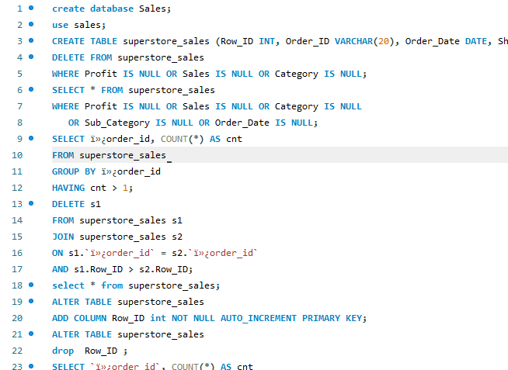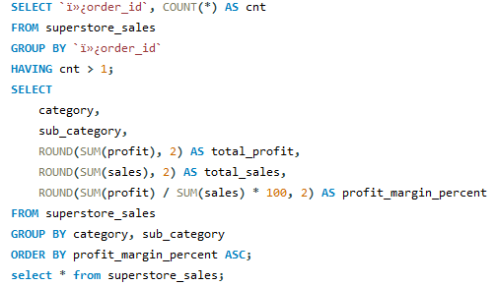

**Python (Panda code used)**

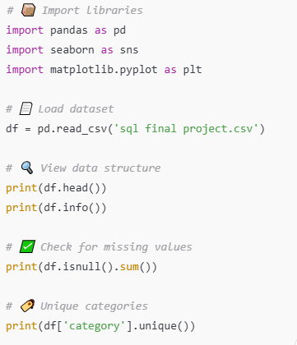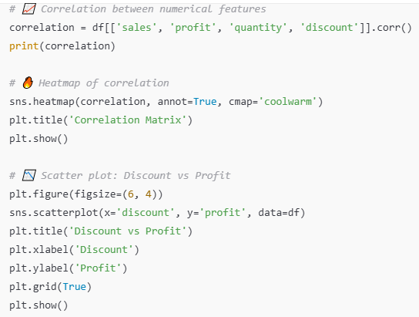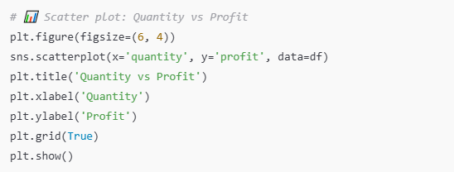

**PowerBI Dashboard**

